BRANDING & ATTRACTION INFORMATION  Hours of Operation:  Please see FAQs on website for updated hours  PLEASE SEE ALL ASSETS HERE AND ON THE LAST PAGE | 

All Available ESB Products for Reference:
Main Deck/Standard  Tickets | Starbucks Reserve Sunrise Experience | Express Tickets

PRESS QUOTES

  “…the revamped observatory is likely to become a must-see,  even for jaded natives.” |   “If you haven’t been since you were a kid or you took your  out-of-town relatives a decade ago, it’s time for another look.” |   “…the Empire State Building is…  the center of it all.”

 |   “The Empire State Building is one of the most recognizable and visited structures in the world, welcoming millions of sightseers each year.”  .” |   “The stunning view from the highest observatory at New York's Empire State Building just got even better.”

OVERVIEW
The Empire State Building (ESB) is the World’s Most Famous Building.
1,454 feet above Midtown Manhattan from ground to the antenna
Open daily – check FAQ page for hours of operation
On a clear day, you can see up to six states.
Entrance
- Grand Staircase with a two-story architectural model of the building
- High-tech LED exhibit that celebrates lighting ceremonies performed by famous, celebrity guests
- Express guests receive red carpet VIP treatment

Included in all ticket options:
All signage and exhibits in nine languages | Free Wi-Fi | Visitors are immersed in an interactive museum on their way to the top!  12 galleries from the building’s plans to a selfie with Kong!
Revamped 80th Floor featuring exciting, artistic exhibits and an opportunity to create a customized NYC itinerary with New York City Tourism + Conventions “Above and Beyond” kiosks |  | Only 360-degree  open-air vantage point located in the center of Manhattan

102nd Floor Observatory (for an additional price)
- Floor-to-ceiling windows
- Glass elevator with sound and light experience
- The jewel at the top of the center of New York City

HIGHLIGHTS VERBIAGE
THE EMPIRE STATE BUILDING
HAS BEEN RATED THE #1 ATTRACTION IN THE UNITED STATES BY TRIPADVISOR TRAVELERS’ CHOICE BEST OF THE BEST.
IT IS RANKED THE #1 ATTRACTION IN THE WORLD OVERALL.

RESERVATIONS ARE REQUIRED – Please arrive at your scheduled reservation time to avoid delays and ensure an easy check in process.

Universal Ticket Details
- Get to the top faster! Skip the line with Express Tickets (applicable to Main Deck/Standard Ticket types)
- Immersive, interactive exhibits included in all ticket options
- The only 360-degree interior and exterior views of New York City from the center of Manhattan
- Exit via the historic and iconic Art Deco, Fifth Avenue lobby
- Free admission for children 0-5
FAQs and Information
- FAQ Page: https://www.esbnyc.com/visit/faq
- Eight In-Building Dining Options
- Signage available in nine languages
- The Empire State Building has redefined what it means to be the Number 1 Attraction in the World by Tripadvisor | Article for reference: Link Here
- The Empire State Building ranked as the #1 Attraction in the US and the World by Tripadvisor’s Traveler’s Choice Best of the Best | Article for reference: Link Here

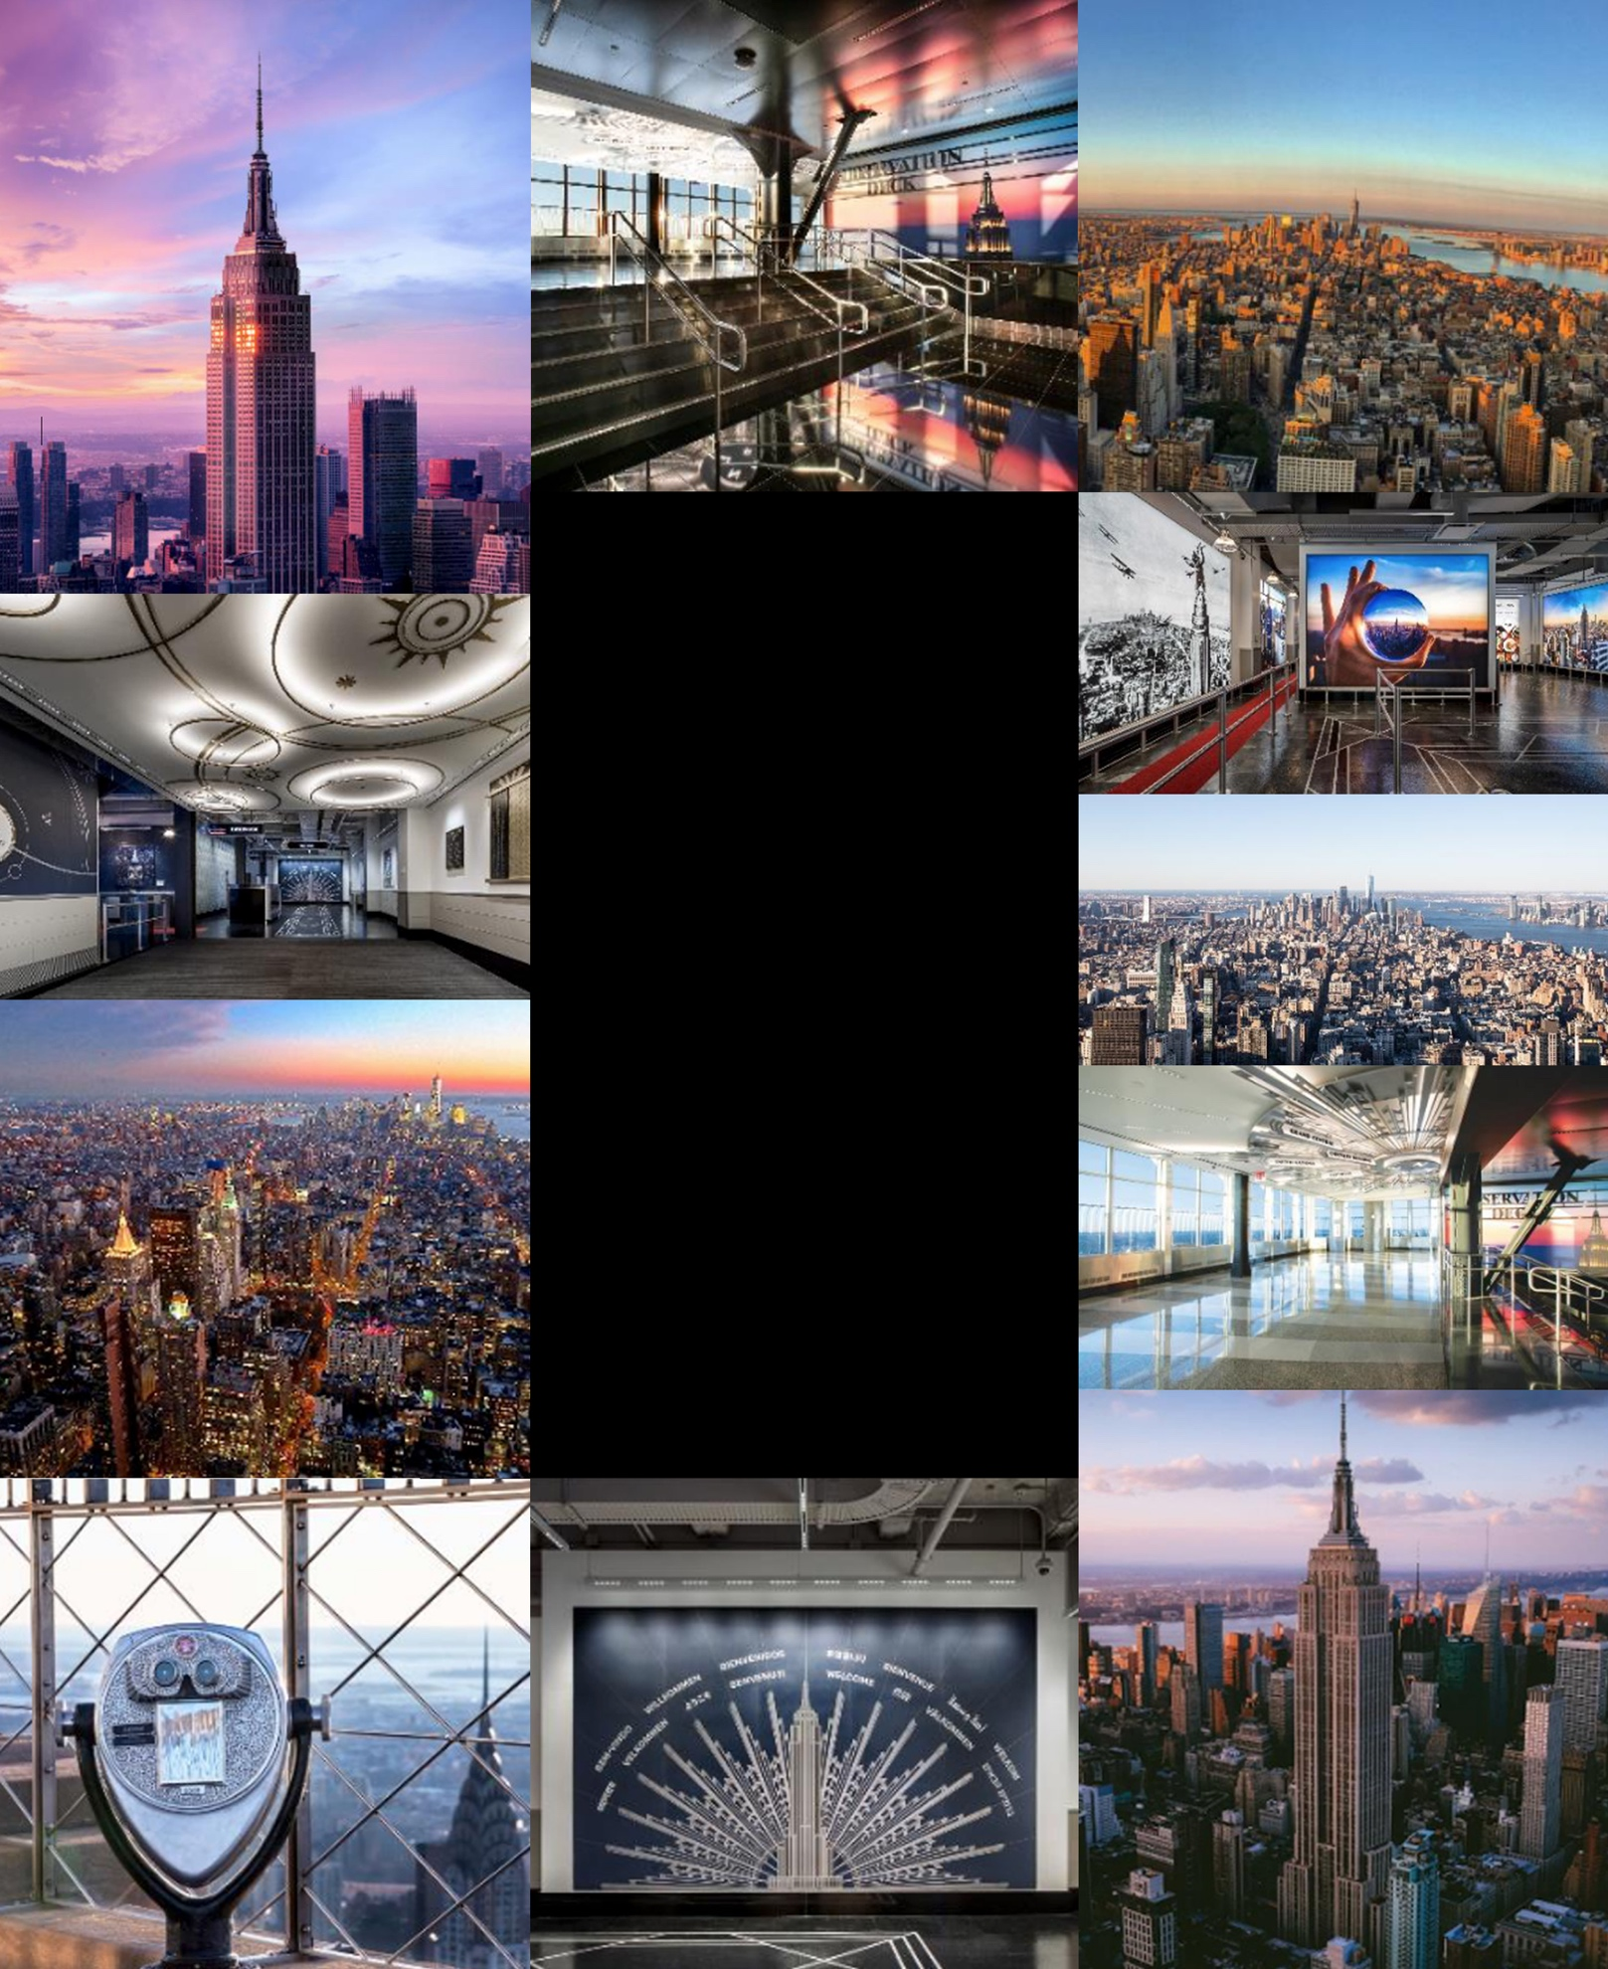

Photography
Standard, Express
Ticket Pages

Photography – Premium Experience Pages
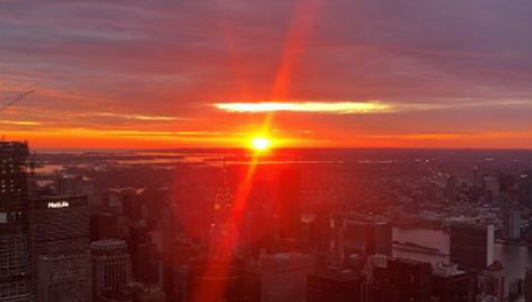  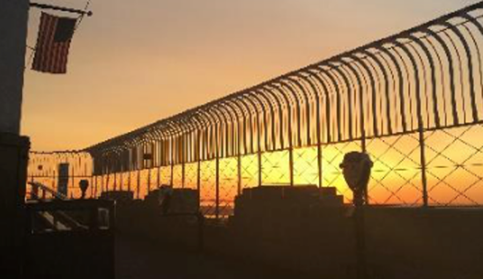 | Sunrise  Experience | 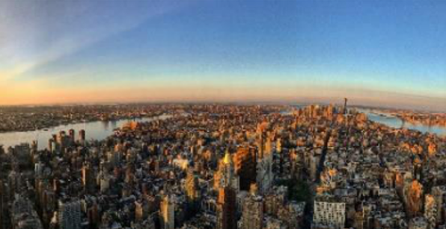  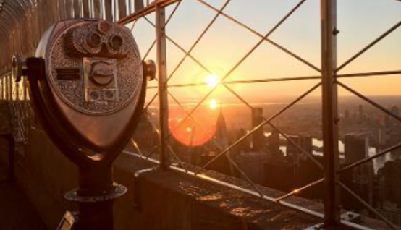

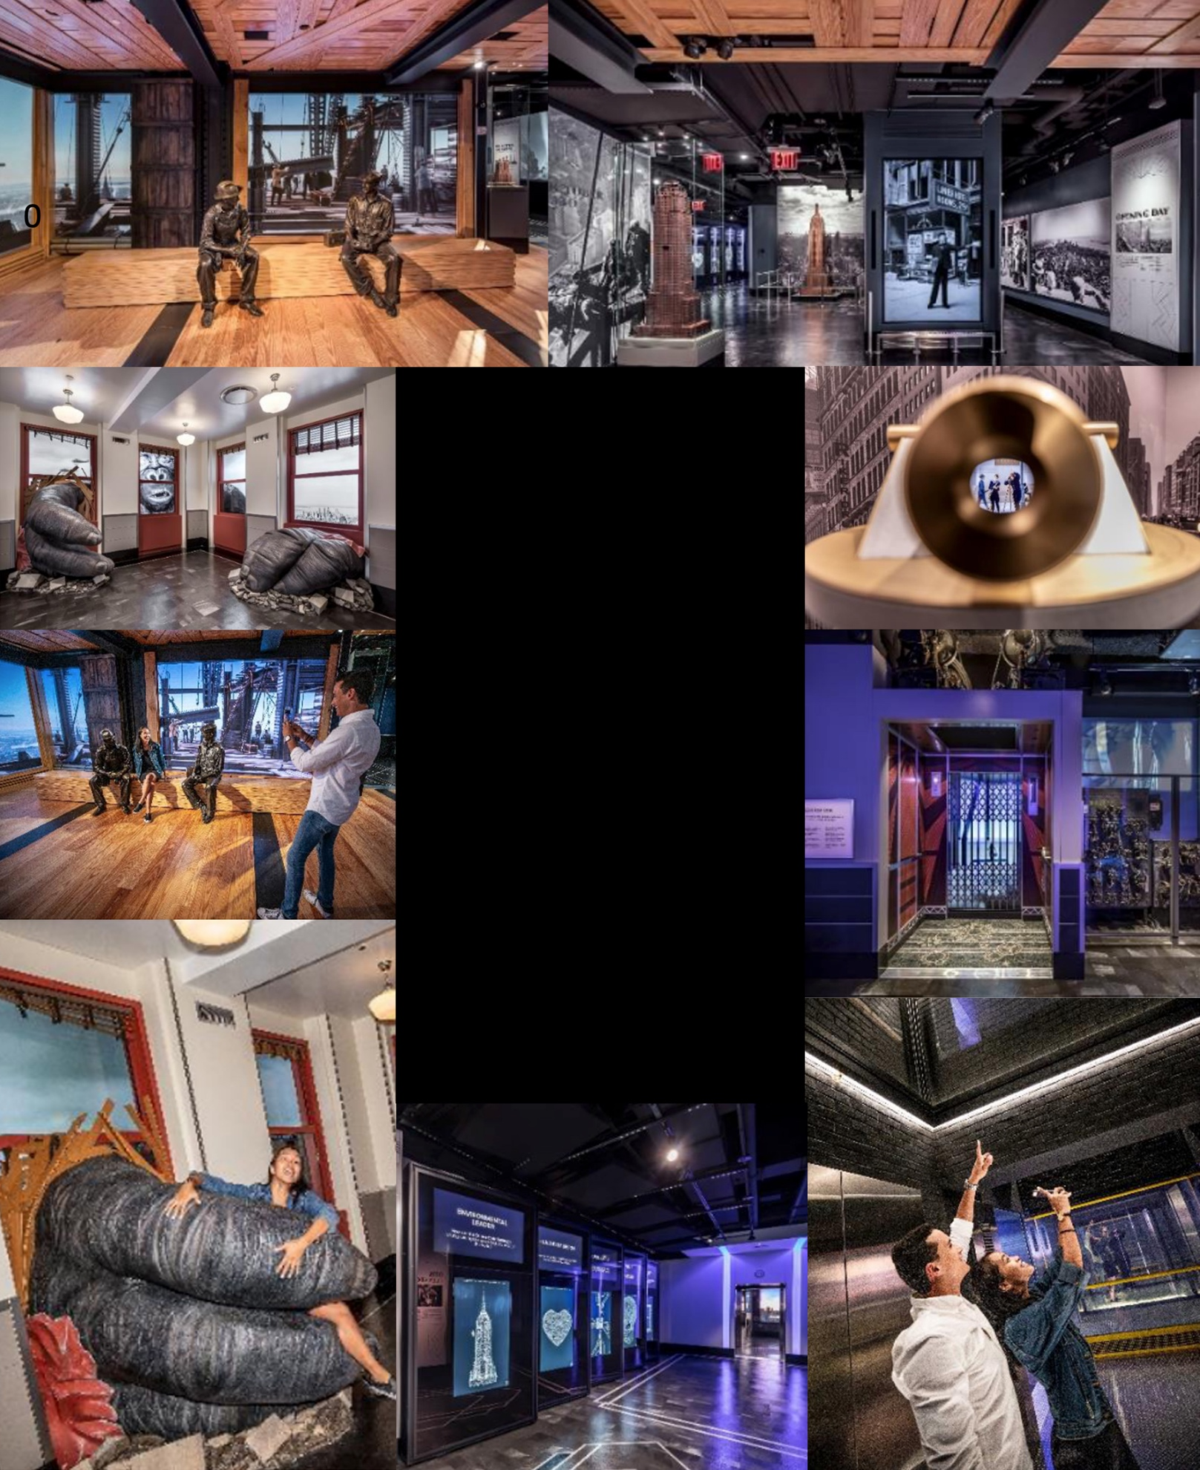

Photography –
Galleries

Photography – 102nd Floor
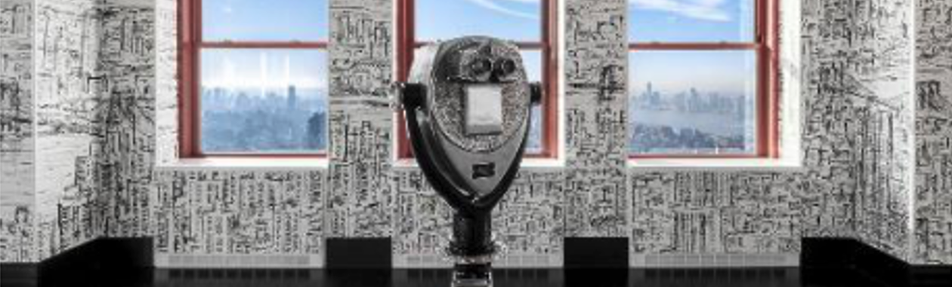
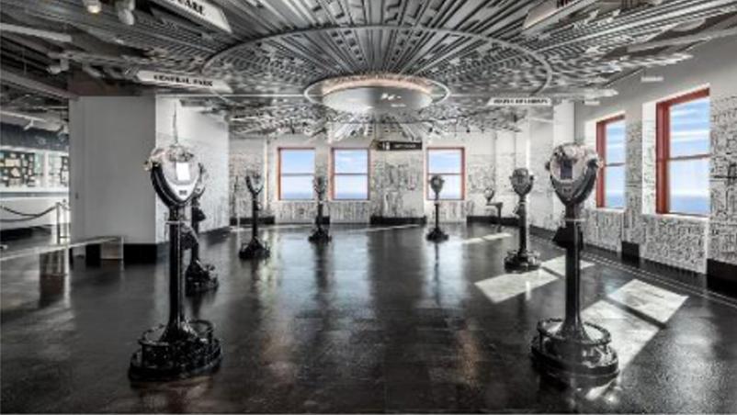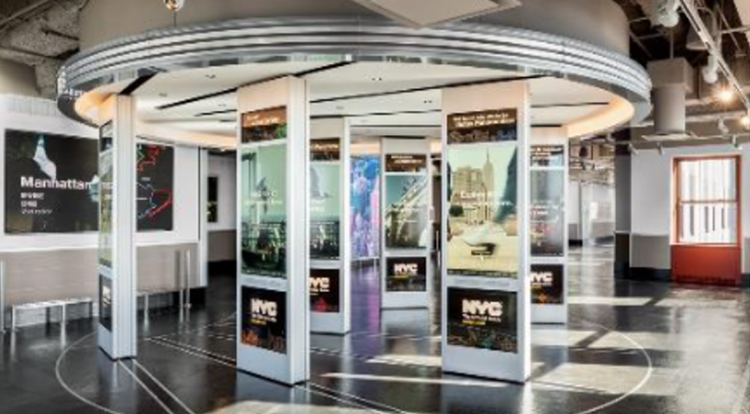
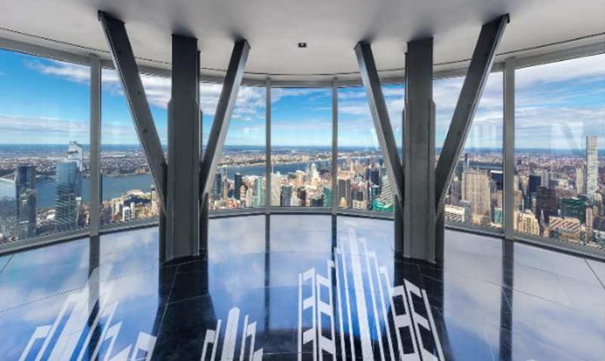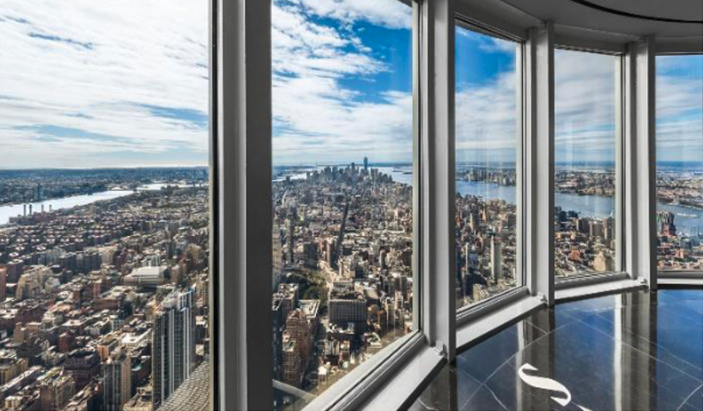
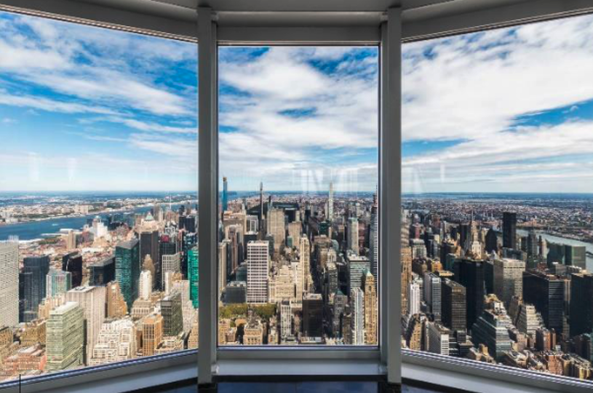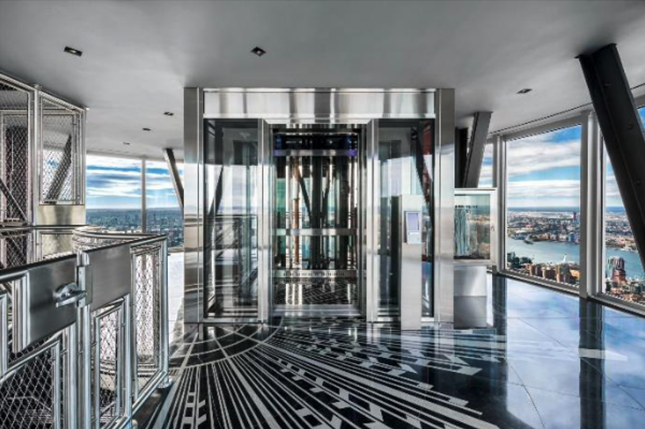

OTA CHECKLIST
Media
- Ensure all photography is up-to-date and high-res
  - Mix of re-designed interior, view from the observatory and exterior of building
  - Confirm that there are no photos of the Sustainability Exhibit, Dare-to-Dream exhibit, old entrance or former 80th Floor
- Photos highlighting the new lobby and experience
- Remove any photos where the deck looks too crowded or appear to be taken from Top of the Rock
- Include up-to-date Video Assets (when applicable)
- Add photos to Premium Experience Pages (when applicable)
- Photography is here.
- Starbucks Reserve Sunrise Experience imagery is here.
- Highlight International Lightings and Moments when necessary:
  - India Day: assets
  - Brazil Day: assets
  - Hispanic Heritage Month: assets
  - Lunar New Year: assets
  - Black History Month: assets
Facts and Information
Contract Information
- Ensure key attraction and visitor information is up to date
- Website Listed
- Observatory Entrance Address & Phone Number
- Hours
Updated Content
- No mention of old exhibits
- Updated overview & highlights sections. Confirm that images of the 2nd floor museum are prominently featured.
- Website Listed
Ticket Descriptions
- Ticket descriptions can be found HERE.

Premium Products listed
- If no – link to website or separate listing
Ensure Facts are relevant and accurate:
- Updated FAQs
- View of up to 6 states – New York, New Jersey, Pennsylvania, Connecticut, Massachusetts, and Delaware
- In-Building Dining

